
ENGR. WALKER'S FAMILY
Walker’s Family
22 Burney St,
London SE10, UK,
London, United Kingdom

_______________________________________________
16/05/ 2019
Position Reference: AUPAIR
APPROVED OFFICIAL LETTER OF APPOINTMENT

BEKCHANOV OTABEK
We would like to offer you the position of an Au pair to our family for a period of 12 Months and could be reviewed if you are willing for an Extension. The terms and conditions of the job are as follows:
You will be required to work for a maximum of 20- 25hours per week. Your weekends could be spent anywhere even with the family going out on tourism or outing.
ACCOMODATION:
You would have a Private Live-Out or Live-In Accommodation depending on your preference with Private Bathroom, Sitting Room and Bedroom. Your room would also be furnished with a Television Set, an Internet Ready Computer System and a Fixed Landline telephone. We ask that all rooms be kept tidy and that friends staying over should only do so with our permission. Your room is situated close to the kids room to create a close relationship with them.
SALARY:
You will be paid 680GBP as your Weekly salary, and additional pocket money of 400GBP Monthly as incentives from a loving, sharing family.
START DATE AND PERIOD OF EMPLOYMENT:
You are expected to start your duties as soon as you arrive and to stay for a minimum period of 12 Months, If due to circumstances beyond your control or for any other reason, you wish to leave at an earlier date than our agreement, you will be required to give one month notice. If we require you to leave, subject to the conditions specified under ‘discipline’, we will give you a minimum of one month notice. This agreement of period could be reviewed at the end of the contract if you wish or find our family lovely.
RESPONSIBILITIES AND DUTIES:
Basically, your duty is to take care of the kids, and all we require is care and love. This could be manifested by devotion to their needs and going on outings with them since they like going to parks and companionship.
DISCIPLINE:
Reasons which could give rise to disciplinary measures are as follows:
Causing a disruptive influence in the household,
Insubordination and incompetence in duties,
Misconduct during or outside working hours prejudicial to our interests,
Failure to comply with our reasonable instructions or procedures.

In the event of a need for disciplinary action, the procedure will be:

First - a verbal warning,
Second - a written warning,
Third - dismissal without need for further notice.

Reasons which would give rise to summary dismissal would be:
Theft or other dishonest offences including unlawful ganging,
Regular Drunkenness,
Illegal drug taking,
Child abuse or neglect.
We look forward to having you with us and we are making sure that our association will be a long and happy one.
Please sign a copy of this letter as acceptance of its terms and conditions and send a signed copy to Att. James Evans (attorney_j.evans@outlook.com) .

Yours faithfully

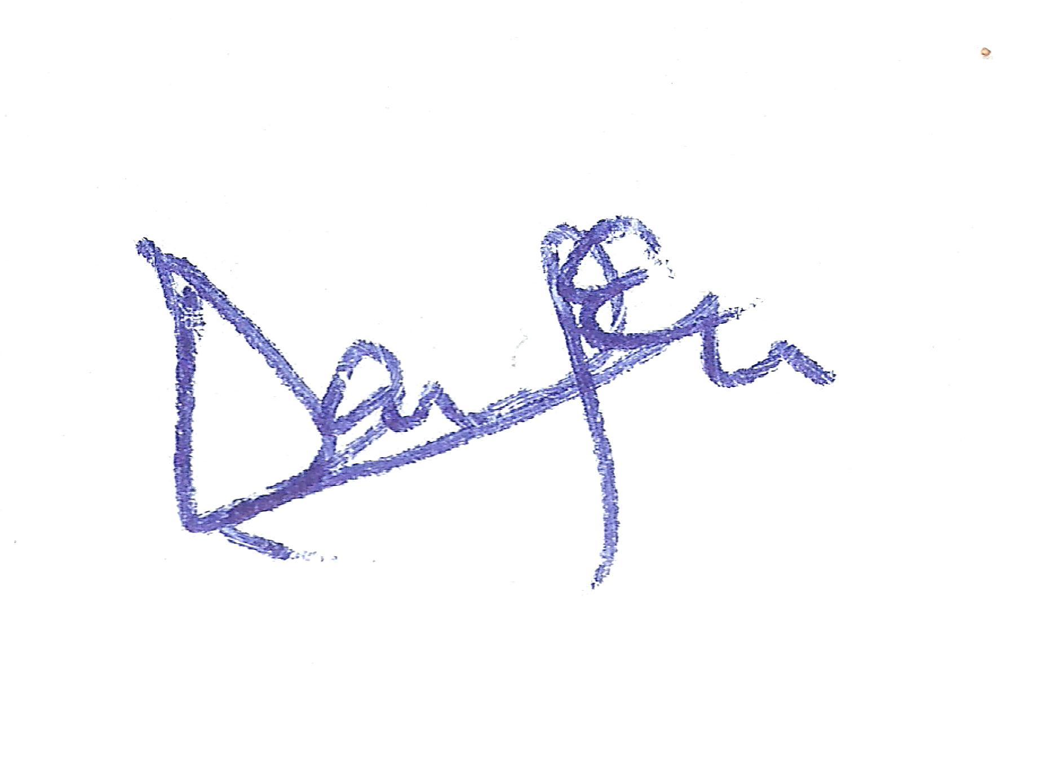
Employer

Engr. Walker’s Family

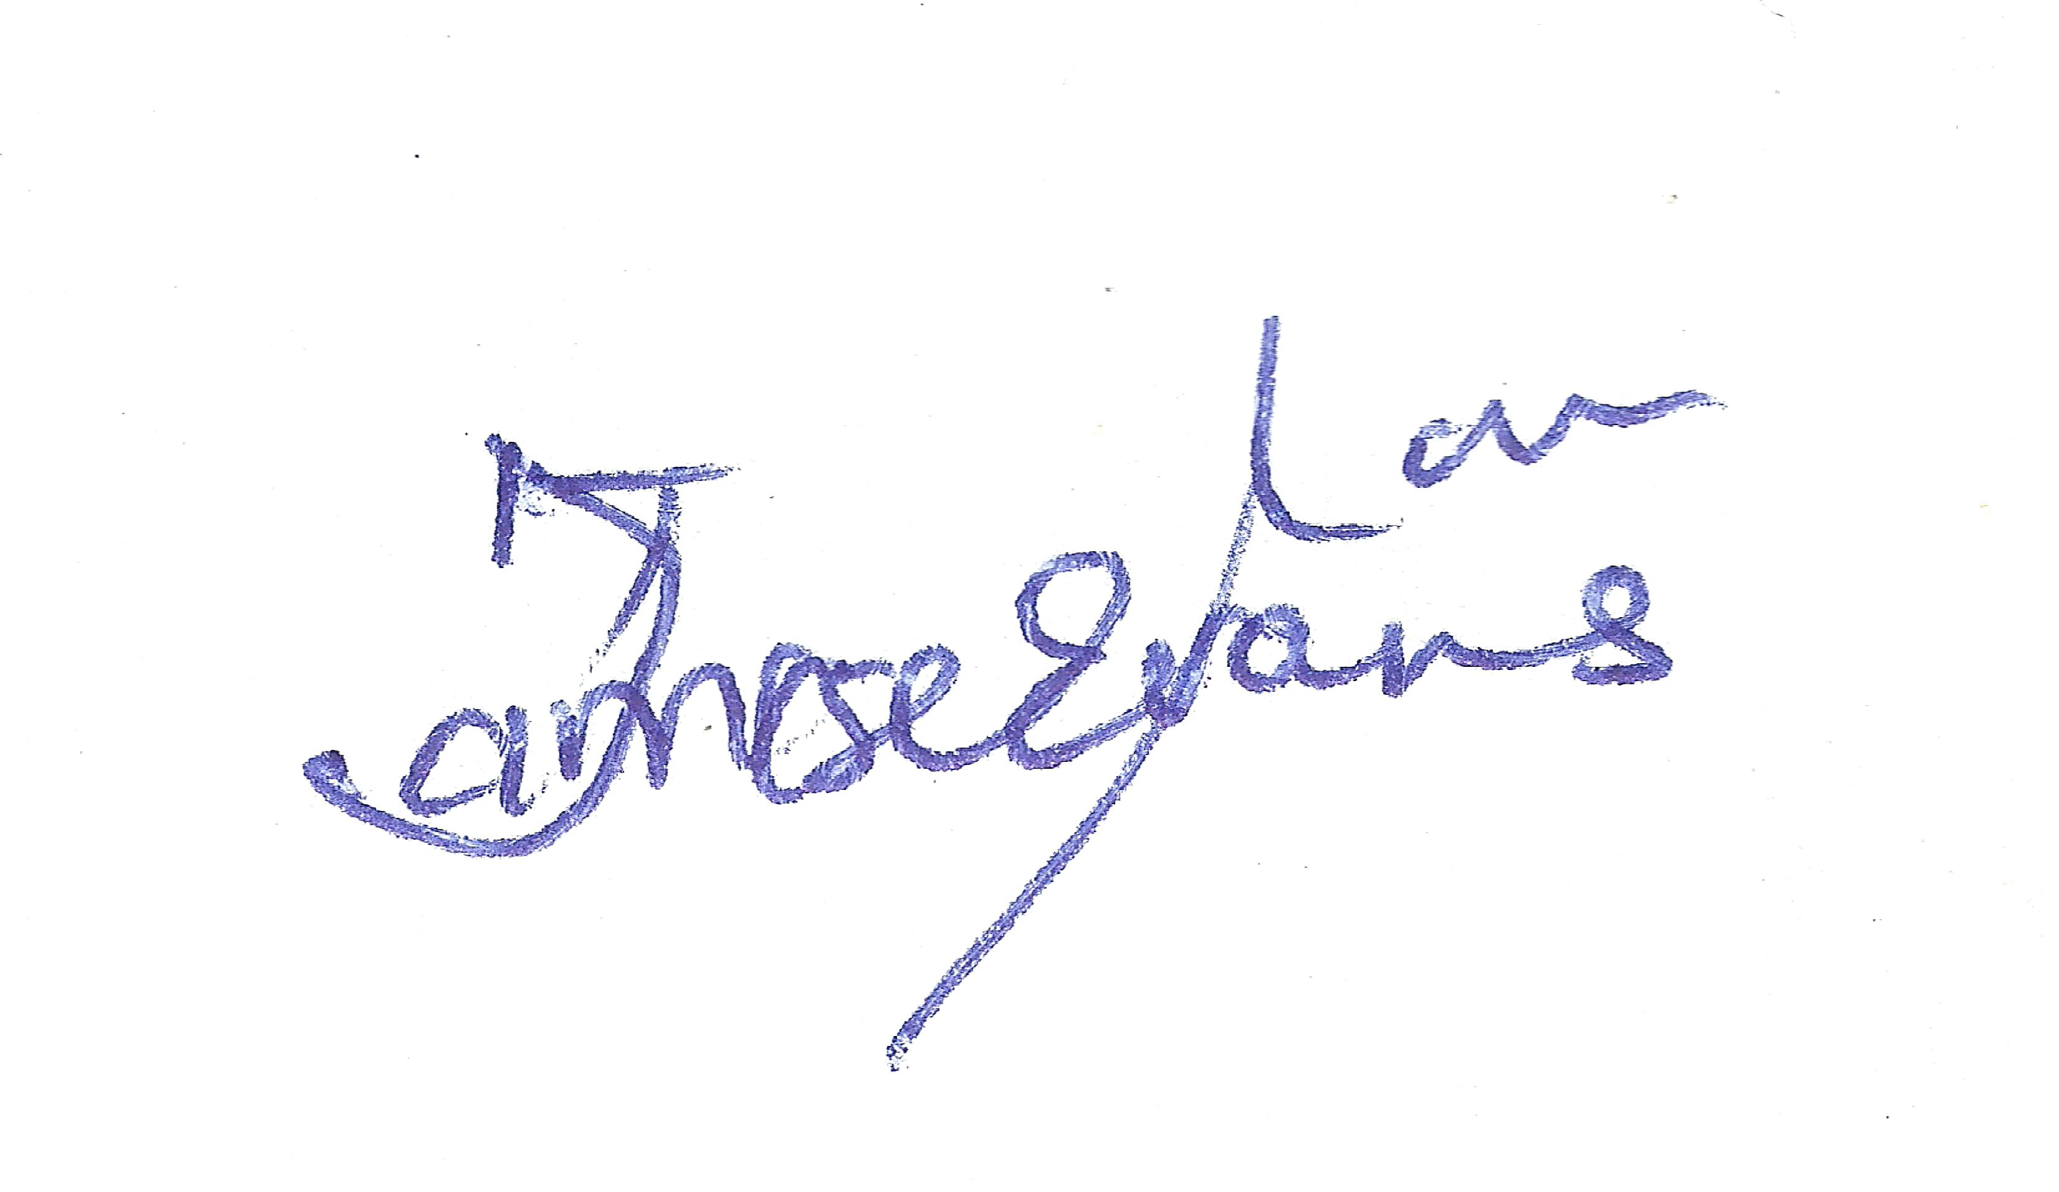
UK Home Office Associate Attorney

Att. James Evans
I have read and accepted the above terms and conditions.

………………………………………… …..………………………….
Surname First Name Employee Date/Signature.

*HOME OFFICE REPRESENTATIVE*
*HOME OFFICE REPRESENTATIVE*

